Question 1:

Which of the following is a single byte of digital information?

1. 1101010
2. 000
3. 10
4. 10101101
5. 101011010111

Question 2:

You're visiting a Computer Science building at a college, and they've decided it'd be fun to display all the room numbers in binary. You're going to room 13.

What binary number should you look for on the door?

Question 3:

Modern car dashboards contain a number of visual indicators to help drivers be safer, more responsible drivers.

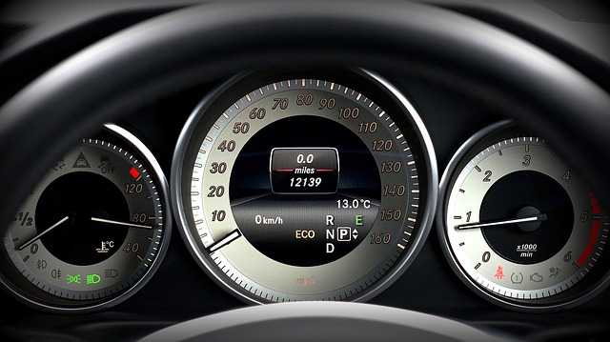

Which of these indicators could be represented by a single bit?

Question 4:

A website decides to use 10-digit hexadecimal numbers as unique identifiers for their users. Here are a few examples:

* 1FEBCD128B
* 79ACAA349F
* 674ABF9872

What's the maximum number of users that can be represented with these identifiers?

Question 5:

A bunch of computer scientists take over an island and start their own country. They want the license plates to use binary numbers. There's space for 7 digits on each license plate and the first plate starts at 0000000.

How many unique license plates can their country support?